📄 AWS S3 Bucket Attack & Defense Lab Report

Created By:
Rituraj Singh

1. Title
AWS S3 Public Bucket Misconfiguration & Remediation using Static Website Hosting

2. Objective
The objective of this lab is to understand how misconfigured AWS S3 buckets can lead to public data exposure, and how to identify, exploit, and fix such vulnerabilities using AWS security controls.

3. Overview
In this lab, we performed a practical demonstration of:
- Creating an S3 bucket with public access enabled
- Uploading a file and exposing it using Static Website Hosting
- Attempting public access via browser
- Encountering an AccessDenied (403 Forbidden) error
- Fixing the issue by applying a Bucket Policy
- Successfully accessing the file publicly
- Securing the bucket again using Block Public Access

4. Prerequisites
- AWS Account
- Basic knowledge of Amazon S3
- Internet browser (Incognito mode for testing)

5. Lab Implementation

Step 1 – Create Test Bucket
- Open AWS Console → Amazon S3
- Click Create Bucket
- Bucket name: lab-public-bucket-<random>
- Region: us-east-1
- Disabled Block All Public Access
- Created the bucket
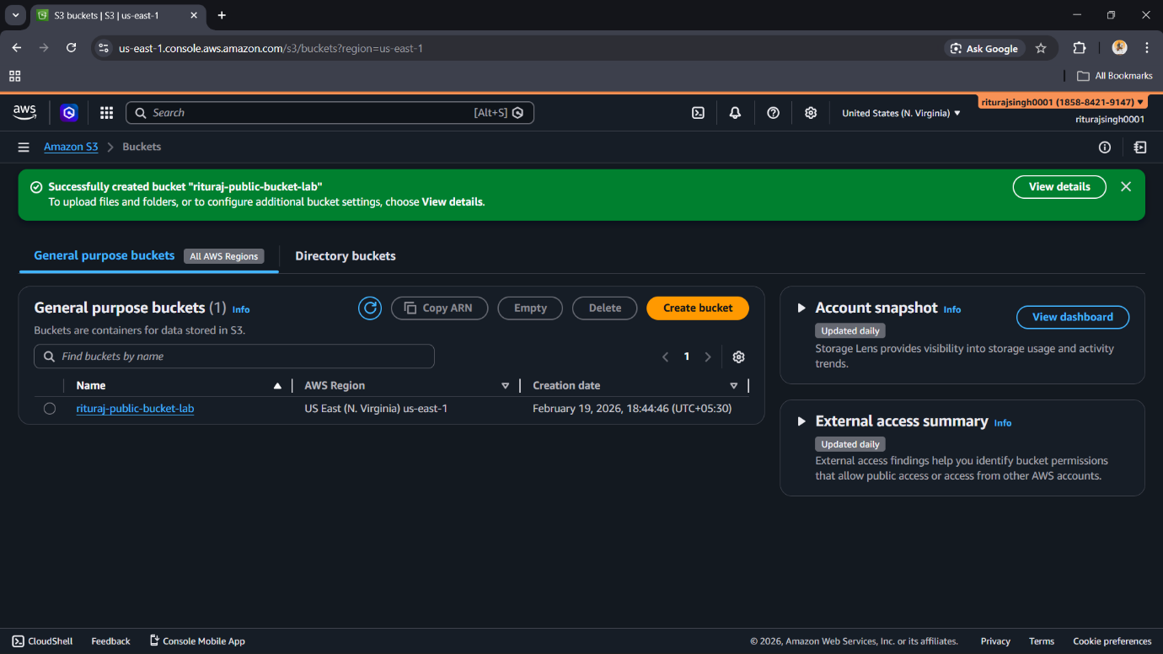
✅ This configuration makes the bucket potentially vulnerable to public exposure.

Step 2 – Upload a File
- Open bucket → Objects tab
- Click Upload
- Uploaded file: hello.txt
File Content:
Hello,
This is demo lab
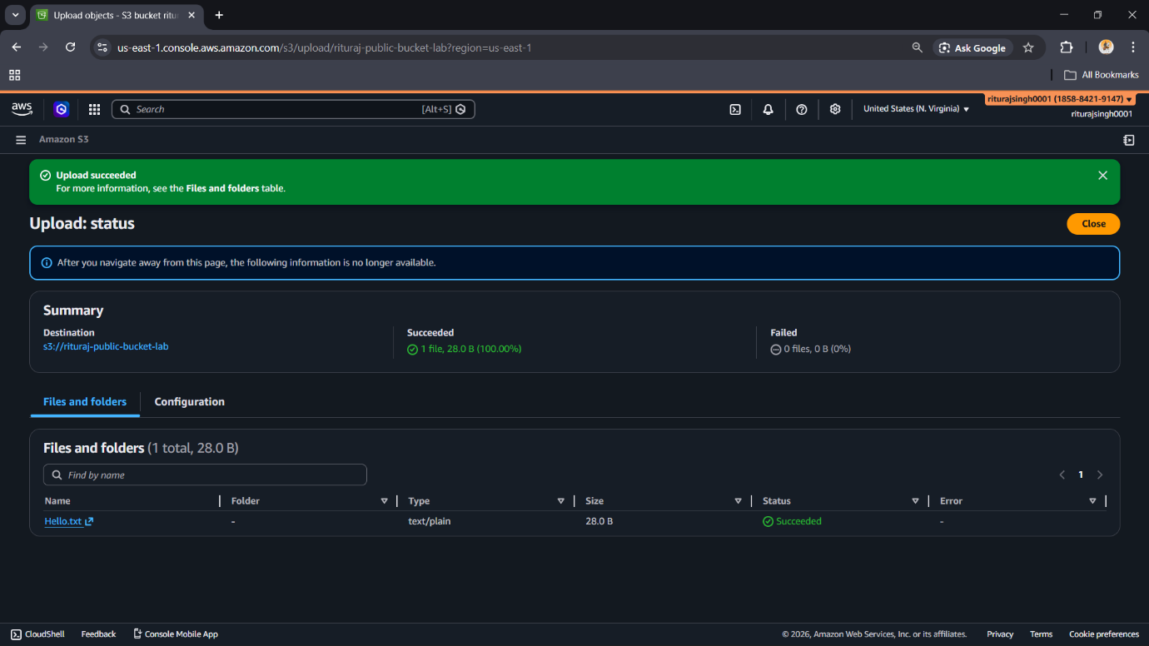

Step 3 – Enable Static Website Hosting (Attack Simulation)
- Go to Properties tab
- Enable Static Website Hosting
- Hosting type: Bucket hosting
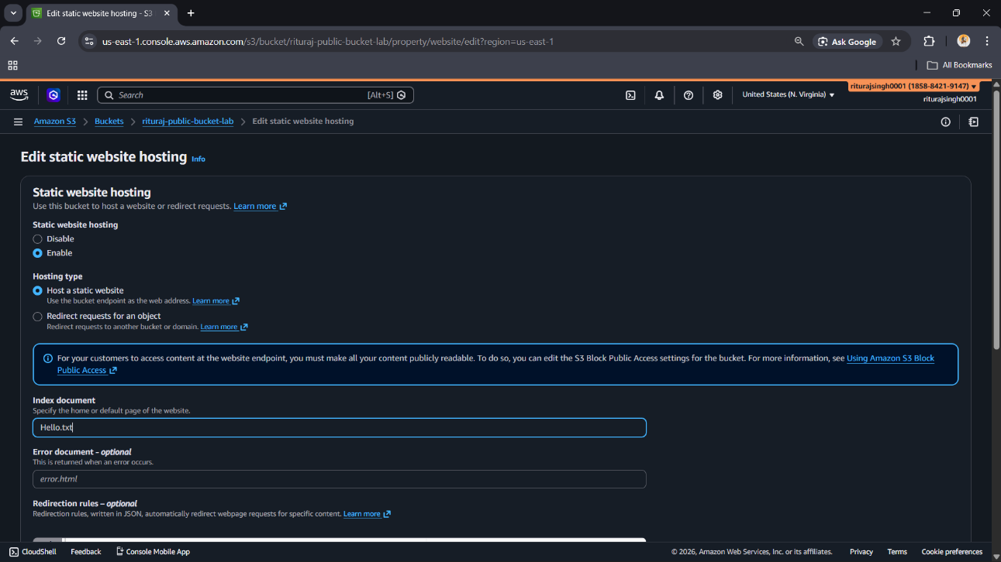
- Index document: hello.txt

- Saved changes
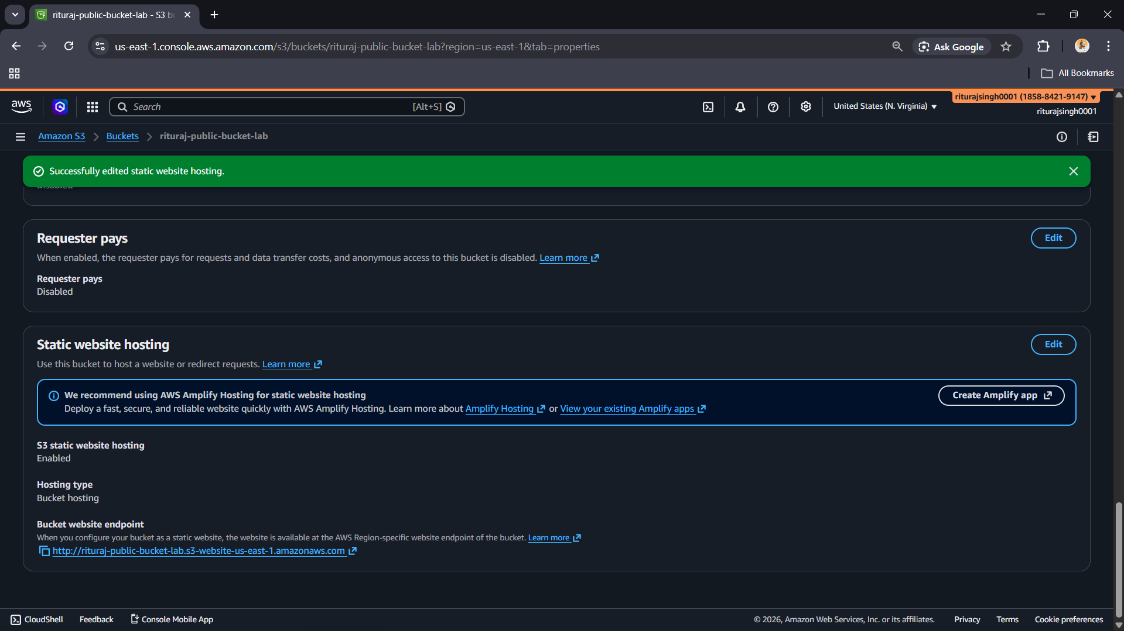
- Copied website endpoint:
http://lab-public-bucket-xxxx.s3-website-us-east-1.amazonaws.com
Opened in Incognito Mode

❌ Issue Encountered: 403 Forbidden Error
Instead of accessing the file, the following error was observed:
403 Forbidden
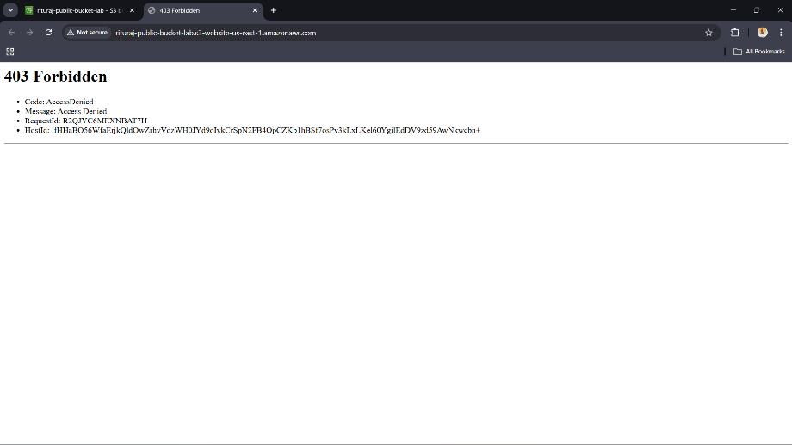
Code: AccessDenied
Message: Access Denied

6. Root Cause Analysis
The error occurred because:
- Static Website Hosting was enabled ✅
- BUT public read permissions were NOT granted ❌
👉 AWS S3 requires explicit permission using:
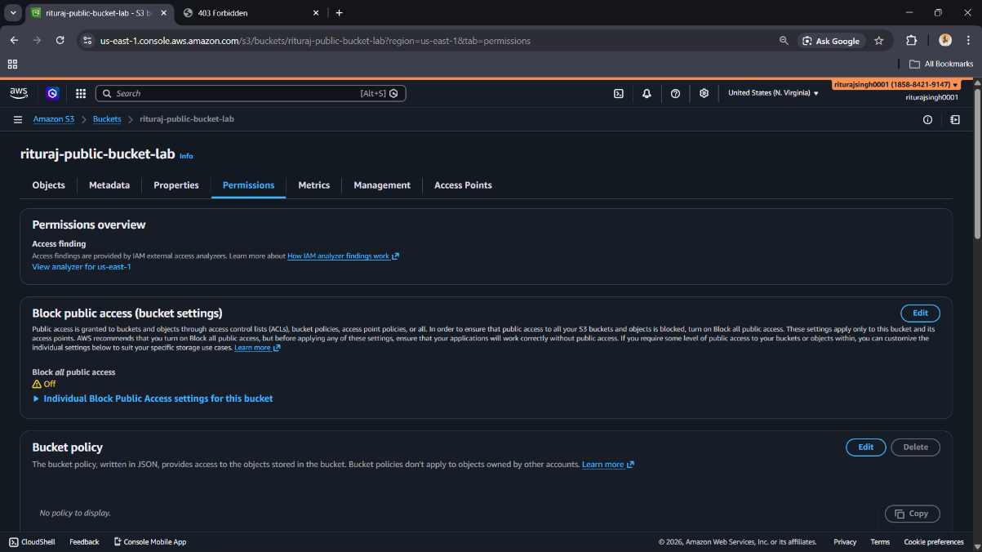
- Bucket Policy

Without this, anonymous users cannot access data.

7. Fix – Applying Bucket Policy (Critical Step)
To resolve the issue, a Bucket Policy was added:
{
"Version": "2012-10-17",
"Statement": [
{
"Sid": "PublicReadAccess",
"Effect": "Allow",
"Principal": "*",
"Action": "s3:GetObject",
"Resource": "arn:aws:s3:::your_bucket_name_/*"
}
]
}
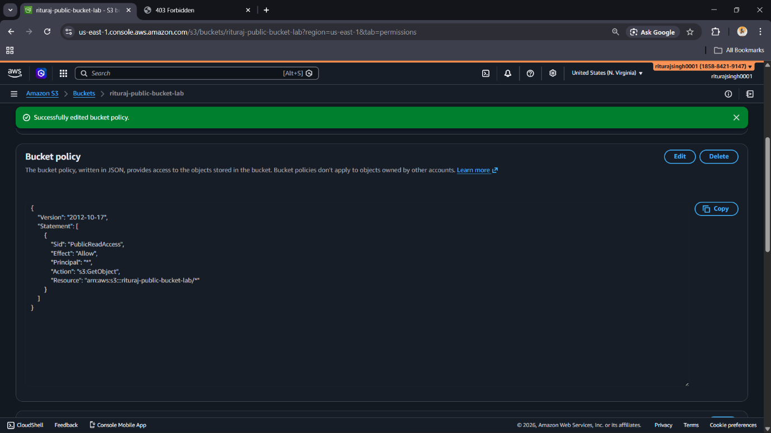

✅ This policy allows:
- Public users (*)
- To perform s3:GetObject
- On all objects inside the bucket

✅ Result After Fix
- Opened website endpoint again in incognito
- Successfully accessed content:
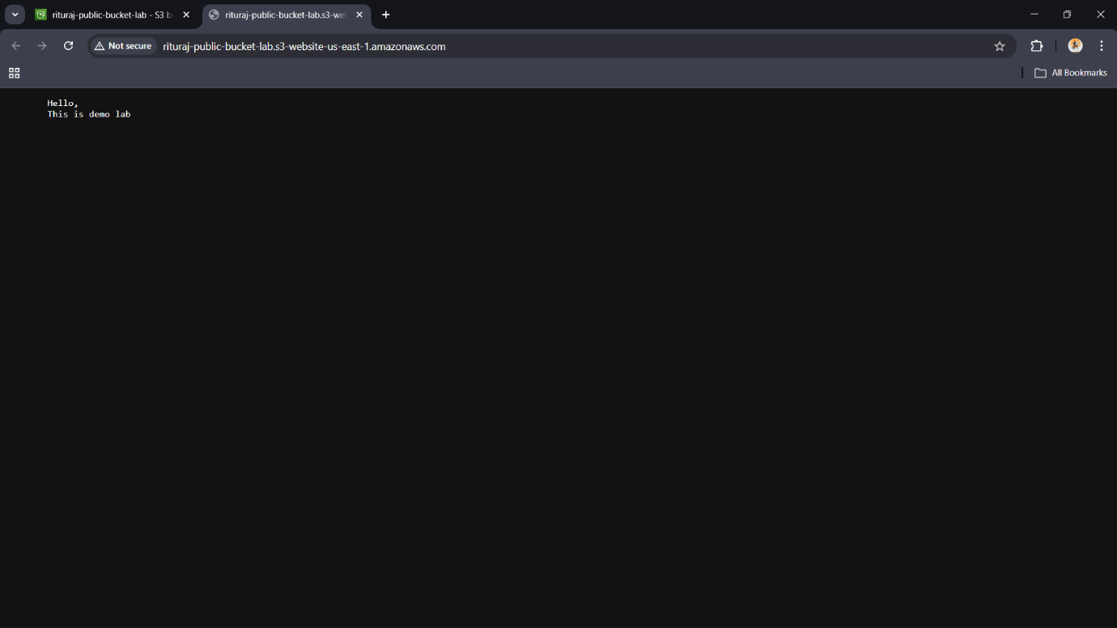
8. Security Risk (Attack Perspective)
This configuration demonstrates a real-world vulnerability:
- Sensitive data can be exposed publicly
- No authentication required
- Anyone with the URL can access data
👉 This is a common cloud misconfiguration vulnerability

9. Defense – Securing the Bucket
To mitigate the issue:
- Enabled Block Public Access
- Removed public access permissions
- Ensured no public bucket policy exists

🔒 Verification
- Opened website endpoint again
- Received:
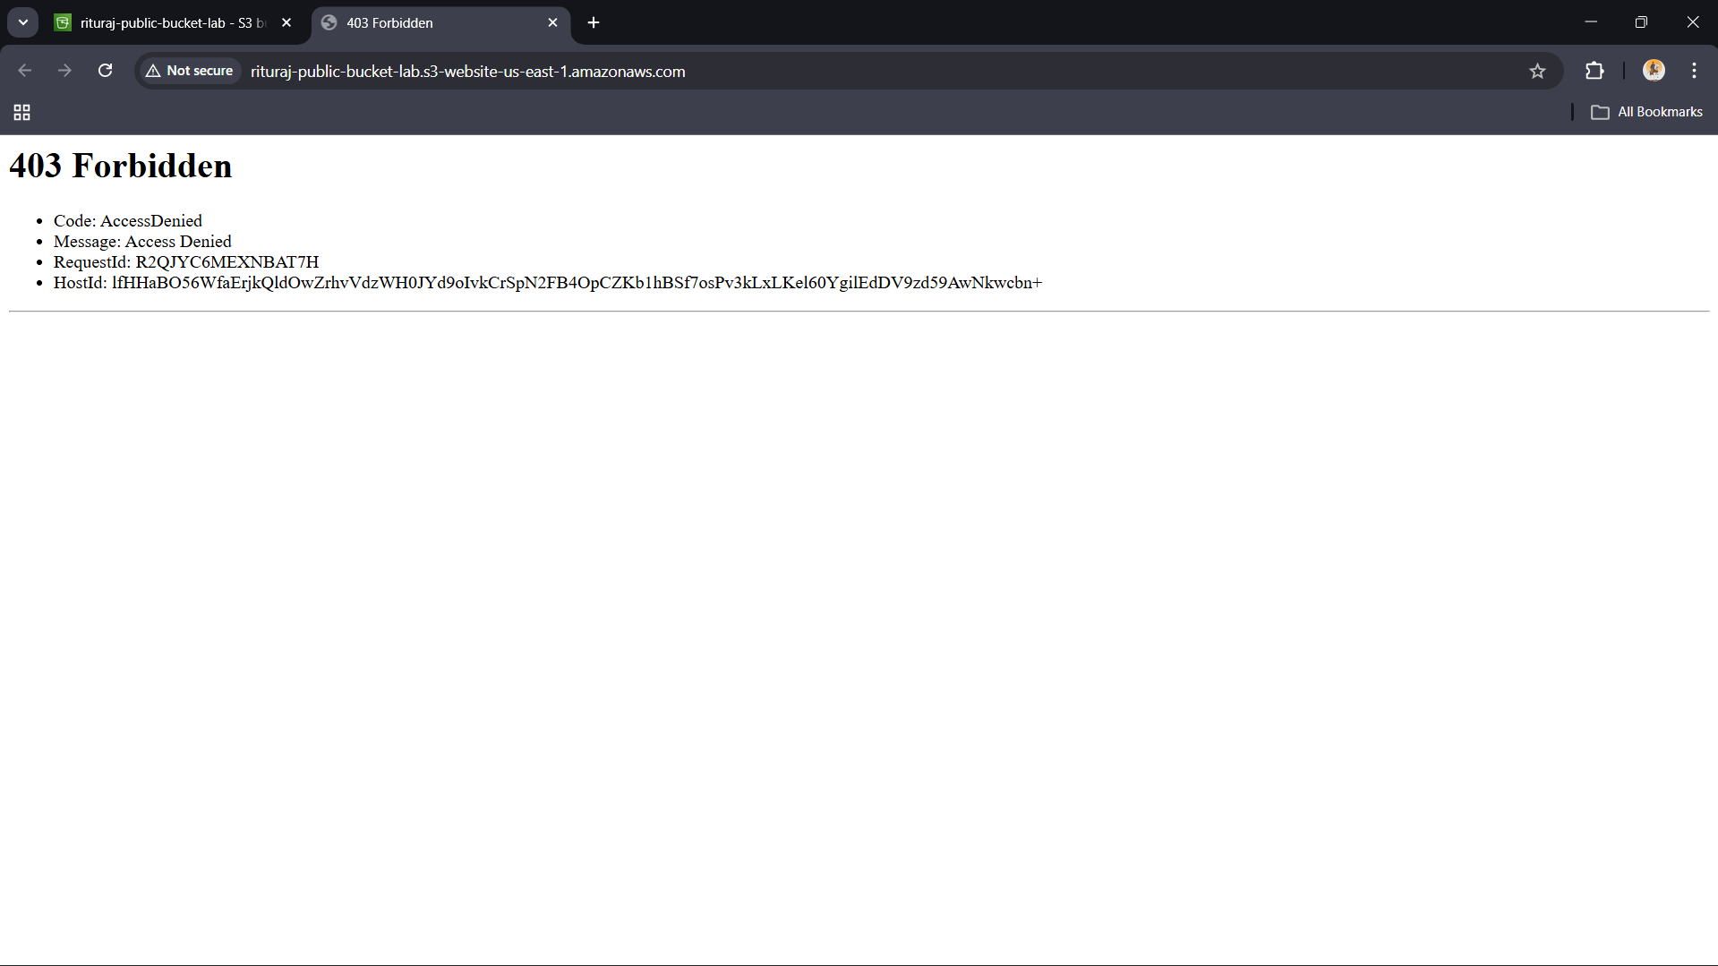

10. Cleanup
- Deleted hello.txt
- Deleted S3 bucket

11. Conclusion
This lab demonstrated that:
- Enabling Static Website Hosting alone does NOT make content public
- Improper configurations can lead to data exposure risks
- Bucket Policies play a critical role in access control
- Security best practice is to block public access unless absolutely required

